Shared with permission from Home for Refugees’ March 4, 2021 e-newsletter, Creating Home

Elbow Pound to Friendship
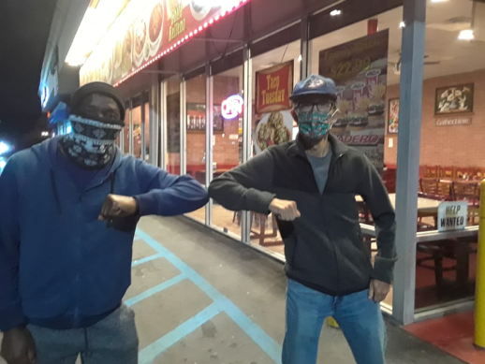
To honor Black migrants this month, we are highlighting Albert and his Home Team’s story. Albert is an asylum-seeker from Cameroon. Cameroon is currently experiencing a civil war and Albert was violently targeted which forced him to escape. Last March Albert and members of his Home Team (his Community Sponsorship Team) had no idea what a year of resettlement would bring. But all of them are thankful they found friendship in what could have been the most isolating time of their lives.

The benefits of friendship are life-giving and even life-saving. The Book of Ecclesiastes says, “Two people are better off than one, for they can help each other succeed. If one person falls, the other can reach out and help. But someone who falls alone is in real trouble” (Ecclesiastes 4:9).

Albert’s Home Team includes Larry, Les, Dave, and Roberta. The team is a joint venture between Home for Refugees, Haitian Bridge Alliance, and Trinity Presbyterian Church of Santa Ana, CA.

Some team members are retired and are staying at home to protect themselves from COVID, which can be isolating. Albert has felt isolated also as he stays at home not able to work while waiting for his work permit to be granted by the government. But a community developed between the team members in the midst of this reality through words of encouragement, funny videos, and hilarious gif texts over zoom or WhatsApp.

Albert is a Christian and likes to pray at the end of their monthly meetings. Albert's prayers have been a deep encouragement for the other team members. Likewise, the weekly delivery of food and supplies from “Mum” Roberta to Albert’s home has brought new smiles to all of his apartment-mates.

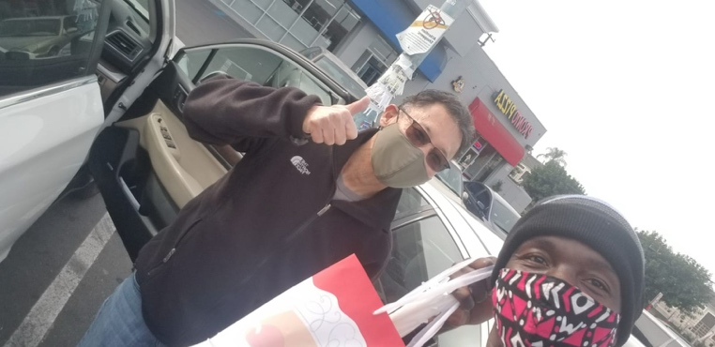
This is how friendship blossomed out of the reality of COVID. What could have been isolation, turned into a friendship that is worth elbow pounding for!

